Name of Student: Aniruddha Prata[p Singh | PRN:25070122247
Semester: III | Year : AY 2026-27
Subject: Programming with Java
ASSIGNMENT No : 6
TITLE : Inner and Anonymous Classes
Problem Statement
Write a Java program to demonstrate the use of an inner class, an anonymous class.
Learning Objectives
To implement inner classes and anonymous classes for improving encapsulation and event handling in Java.

Programme:
/**
* index
*/
class College {
String collegeName = "SIT PUNE";
// Inner Class
class Student {
void display() {
System.out.println("Student belongs to " + collegeName);
}
}
}
interface Greeting {
void sayHello();
}
public class index {
public static void main(String[] args) {
// Inner class object
College college = new College();
College.Student student = college.new Student();
// Call display() method
student.display();
// Anonymous class
Greeting g = new Greeting() {
@Override
public void sayHello() {
System.out.println("Hello from anonymous class ");
}
};
// Call interface method
g.sayHello();
}
}

Output
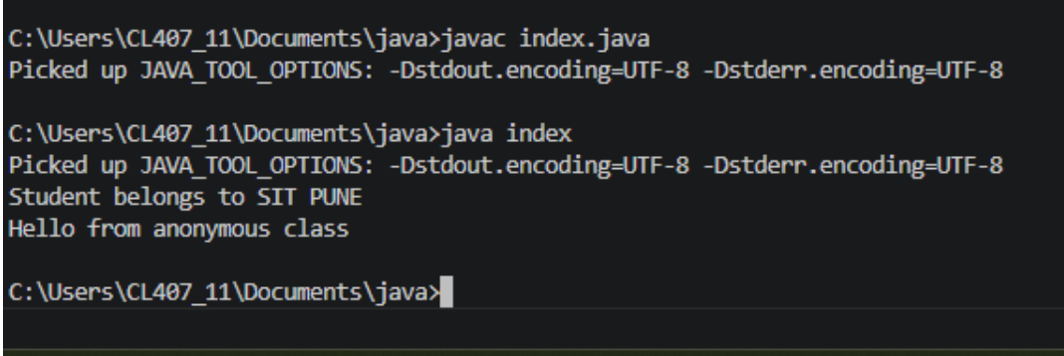

EXERCISE
6.1 .Create a Vehicle program where an inner class displays vehicle details and anonymous class performs an action.
Program 6.1 -
class Vehicle {
String vehicleName = "Honda City";
String type = "Car";
int speed = 120;
// Inner Class
class Details {
void displayDetails() {
System.out.println("Vehicle Name : " + vehicleName);
System.out.println("Vehicle Type : " + type);
System.out.println("Top Speed : " + speed + " km/h");
}
}
}
// Interface
interface Action {
void performAction();
}
public class VehicleDemo {
public static void main(String[] args) {
// Create Vehicle object
Vehicle vehicle = new Vehicle();
// Create Inner Class object
Vehicle.Details details = vehicle.new Details();
// Display vehicle details
details.displayDetails();
// Anonymous Class
Action action = new Action() {
@Override
public void performAction() {
System.out.println("Vehicle is now moving...");
}
};
// Perform action
action.performAction();
}
}
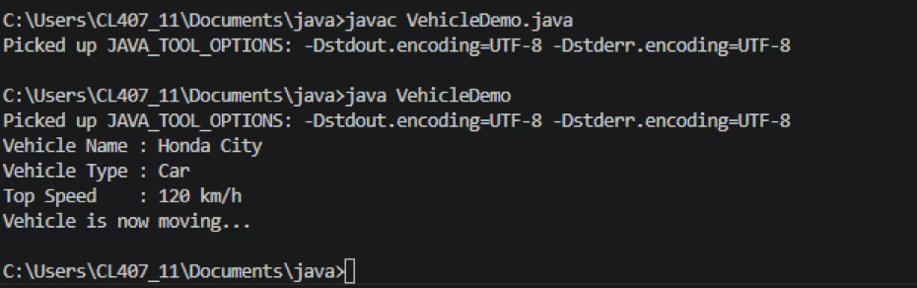
6.2 Develop a Food Delivery Application where an inner class handles order details and anonymous classes handle delivery status updates.
Program 6.2 -
class FoodDelivery {
String customerName = "Sourabh Gupta";
String foodItem = "Veg Burger";
int quantity = 2;
// Inner Class
class OrderDetails {
void displayOrder() {
System.out.println("Customer Name : " + customerName);
System.out.println("Food Item : " + foodItem);
System.out.println("Quantity : " + quantity);
}
}
}
// Interface
interface DeliveryStatus {
void updateStatus();
}
public class FoodDeliveryDemo {
public static void main(String[] args) {
// Create FoodDelivery object
FoodDelivery order = new FoodDelivery();
// Create Inner Class object
FoodDelivery.OrderDetails details = order.new OrderDetails();
// Display Order Details
details.displayOrder();
// Anonymous Class
DeliveryStatus status = new DeliveryStatus() {
@Override
public void updateStatus() {
System.out.println("Order is out for delivery.");
}
};
// Update Delivery Status
status.updateStatus();
}
}
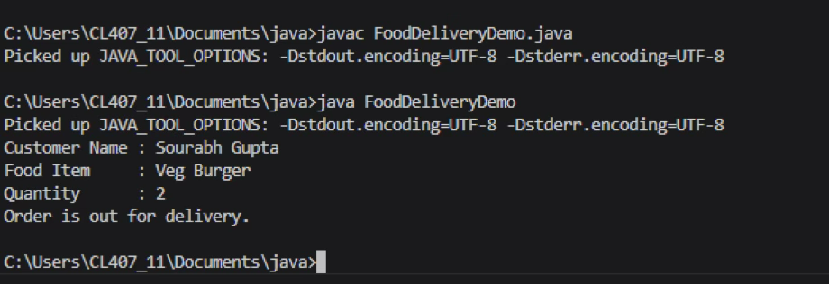
Conclusion
In this experiment, I successfully implemented and verified the working of inner classes and anonymous classes in Java.
- Inner Classes: Demonstrated using Student, Details, and OrderDetails, which made it simple to group related logic together while directly accessing outer class variables.
- Anonymous Classes: Demonstrated through the Greeting, Action, and DeliveryStatus interfaces, showing how to cleanly implement quick, one-time behaviors without cluttering the project with extra class files.

